T-SHIRT & SWEATSHIRT ORDER FORM

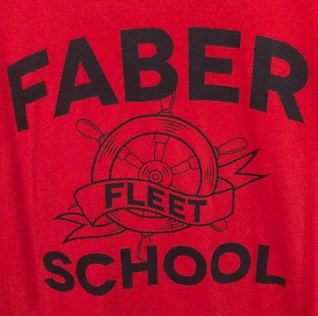 | Faber Fleet  Red t-shirt or hoodie sweatshirt  $10 t-shirt  $20 sweatshirt  Add $3 for 3x or 4x | 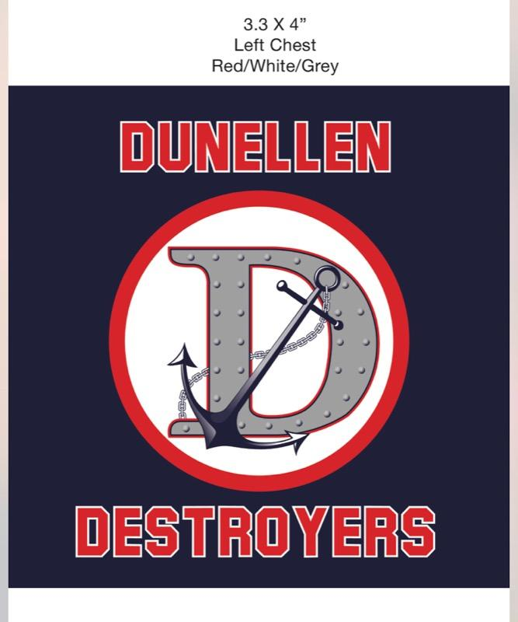 | D with Anchor  Navy long sleeve t-shirt $15  Or Navy hoodie with Dunellen down sleeve $25  Add $3 for 3x or 4x
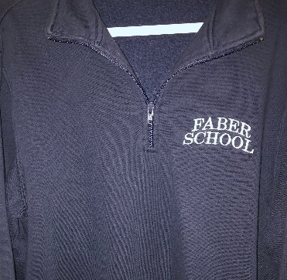 | **SALE** While Supplies Last**  Faber School  Navy half-zip sweatshirt  $30 NOW $25 |  | **SALE** While Supplies Last**  Dunellen  Red half-zip sweatshirt  $30 NOW $25  or $35 NOW $28 (or 2 for $50) with pockets

STYLE | PRICE | SIZE | Additional $3 for 3x or 4x | TOTAL DUE
Faber Fleet t-shirt  Sizes: YS-YL; S-4X | $10
Faber Fleet sweatshirt  Sizes: YS-YL; S-4X | $20
D with Anchor long sleeve tshirt  Sizes: S-4X (ADULT SIZES ONLY) | $15
D with Anchor Hoodie with Dunellen on sleeve  Sizes: S-4X (ADULT SIZES ONLY) | $25
Faber School sweatshirt  Sizes: S-4X (ADULT SIZES ONLY) | $25
Dunellen sweatshirt RED  Sizes: S-4X (ADULT SIZES ONLY) | Low  Stock |  | Please contact us before ordering
Dunellen sweatshirt with pockets RED  Sizes: S-4X (ADULT SIZES ONLY) | Low  Stock |  | Please contact us before ordering
Dunellen sweatshirt NAVY  Sizes: S-4X (ADULT SIZES ONLY) | Very Low on Stock |  | Please contact us before ordering
Dunellen sweatshirt with pockets NAVY  Sizes: S-4X (ADULT SIZES ONLY) | Very Low on Stock |  | Please contact us before ordering

You can email your completed form to dunellenschoolspto@gmail.com or
mail it to 400 High Street, Dunellen, NJ 08812 along with your payment.
Payment options include: Cash, Checks payable to Dunellen PTO, and Venmo (@Dunellen-PTO)

Name: __________________________________________________________________________

Student’s Name: ______________________________ Teacher/Grade: __________________

Phone Number: ______________________________ Email Address: ______________________

Please Note: Orders received by 10/15/2022 will be guaranteed by 11/30/2022. Any order received after 10/15/2022 will be based on availability.

